**MERGING THE SMALL FILES IN HADOOP**

**Command to merge the files:**

Hadoop fs -getmerge –nl <source file path> <local system destination path>

**Sample file:**

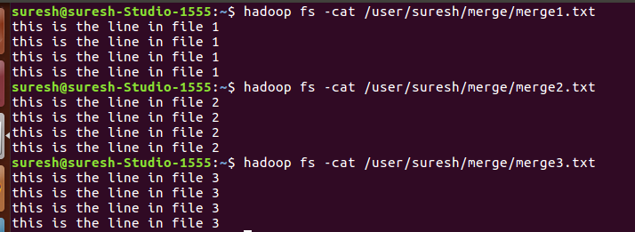

**Merging using the command and output:**

